**Ideas and Benefits**

The primary objective of this paper is to conceptualize and outline a strategic approach for developing a pharmaceutical molecule that makes humans biologically immortal and also potentially reverses aging by the method of extending telomeres. The approach envisions administering the molecule sublingually under the tongue or orally via a capsule, ensuring ease of delivery and maximizing bioavailability.

Holistic Approach: While telomere shortening is a primary cause of aging, addressing other factors holistically is essential. A balanced diet, supplements, and lifestyle changes are necessary to support cellular and mitochondrial health, DNA repair mechanisms, and oxidative stress reduction.

### Reasoning: Why Telomeres?

Telomeres are pivotal in the aging process, serving as the primary regulators of cellular aging and longevity. Addressing telomere length and integrity is crucial for several reasons:

* **Kingpin of Aging:** Telomeres act as the central axis influencing various aging factors. Their shortening is intricately linked with the aging process, and by extending them, we can modulate and reverse other aging factors to youthful levels.
* **Primordial Germ Cells (PGCs):** PGCs are essentially immortal, maintaining their functionality and vitality over time. However, their gene expression and DNA stability alter with age. This alteration is not intrinsic to PGCs but is influenced by the surrounding cells with short telomeres.
* **Reversal of Aging Biomarkers:** Studies on old mice engineered to age by telomere shortening have shown that induced aging through telomere shortening can be reversed. Mice that underwent premature aging due to telomere shortening experienced a reversal in all aging biomarkers once their telomeres were re-lengthened. Organs/bones that had atrophied, like the brain, regained their normal size and functionality, providing compelling evidence of the regenerative potential of telomere extension.
* **Epigenetic Rejuvenation:** There is evidence that the reversal of telomere shortening restores the epigenetic profile of cells to a youthful state indistinguishable from younger cells. This is crucial as epigenetic alterations are significant contributors to the aging process.
* **Addressing Cellular Damage:** Concerning DNA damage, the mitochondria is able to regularly perform "fusion" to repair damage to the cell including the mtDNA. For somatic cells, stem cells harbored in special niches are exposed to as little damage as possible and are able to completely differentiate to replace all these cells. I believe cell death is caused by too many cells becoming senescent, and not cells having minor DNA damage, as there is more than enough cells to make up for the lacking of other cells. This is just not a big deal, not to mention the body has too many mechanisms to deal with this, and in an extremely rare scenario, we could use CRISPR to deliver the missing DNA sequences, but this is unlikely and not the focus of the paper. And concerning general cellular damage, they all get restored to youthful states. The focus of this paper will be rejuvenating a healthy 20-year-old, so DNA damage likely won't be an issue.
* **Long-Term Viability:** Given the evidence, telomere lengthening yields long-lasting results, potentially extending health and vitality for tens of thousands of years or even more (according to image below). The risk of mutations accumulating over such extended periods is acknowledged but is deemed manageable with the advent of technologies like CRISPR and anticipated advancements in medical technology.

(*Image Reversed Aging in Human Cells in Vitro, Reversed Aging in Human Skin (80 year old skin to become identical to young skin in every measure, by the extent of telomere elongation) on Mice, Reversed Aging in Engineered Mice, Nothing Else has even Done Any of these Things, and it is not just talking about a couple biomarkers, it is about every possible measurable biomarker became youthful again, according to Bill Andrews (watch his youtube videos)*)

(*Image Hallmarks of Aging, Loss of Proteostasis, Epigenetic Alterations, Telomere Attrition, Genomic Instability, Cellular Senescence, Mitochondrial Dysfunction, Deregulated Nutrient Sensing, Altered Intercellular Communication, Stem Cell exhaustion)

**Hallmarks of Aging,**

**Loss of Proteostasis** - Proteostasis will return to normal by epigenetic resetting or telomere elongation and telomere elongation can activate epigenetic resetting, making this hallmark of aging become youthful again, as in the studies. There may be bad protein buildup, but these can be cleared by the cell becoming younger.

**Epigenetic Alterations** - Controls the expression of genes, telomere relengthening controls this. However modern "age reversal studies" decide that this is the main cause when it is not, because it doesn't extend telomeres.

**Telomere Attrition** - Main cause of aging. Relatively simple to relengthen in humans.

**Genomic Instability** - Instability arises because of telomere shortening and it can be promptly reversed. Especially in the primordial germ cells, whose maintenance is affected by the surrounding somatic cells.

**Cellular Senescence** - Cells become senescent because there telomeres reach 5000 base pairs. Killing senescent cells via senolytics is bad, especially if you are older, because those cells aren't "dead" they just don't divide, this is why senolytics is bad, according to bill Andrews. This is why senolytics targeting isn't an option. Telomere relengthening can make senescent cells become normal again.

**Mitochondrial Dysfunction** - Returns to normal, we don't age by oxidative stress, but by telomere decline. A study on human skin in a petri dish showed that antioxidants did not cause the cells to exceed the hayflick limit, but telomere elongation did, showing that antioxidants are of little concern, as the body can produce more than enough already. However, mice already have long telomeres and constantly produce it, but they age by oxidative stress and mitochondrial dysfunction, so adding antioxidants to the mice cells made them exceed the hayflick limit.

**Deregulated Nutrient Sensing** - Nutrient sensing, blood health levels and such return to normal.

**Altered Intercellular Communication** - The intercellular communication returns to normal following telomere reextension

**Stem Cell Exhaustion** - Stem cells are harbored in special niches where they are exposed to little damage, but they are not able to divide anymore because telomeres shorten.

**Extracellular matrix Dysregulation** - As seen in the human skin and mouse models, the extracellular matrix becomes normal following telomere re-extension.

How can these beneficial things reduce telomere shortening? They reduce the oxidative damage to telomeres, rather than activating telomerase, and actually the antioxidant buildup is much greater when you do these things rather than stay stagnant, because you build even more antioxidants than when you stay still.

When you do long distance running, you may get sore at first, because you have lots of inflammation in your body, but your body gets used to this. It produces much more antioxidants than if you hadn't, and this is why there are still 80- and 90-year olds that can run marathons.

Extreme muscle building is bad, because you overexhaust your muscle stem cells to produce more muscle cells.

(*Image What We Lose With Age a single celled human has 15,000 base pairs of telomerase, a newborn has 10,000 base pairs, when telomeres get to 5000 base pairs they stop dividing)

Telomeres are crucial components in the aging process, serving as protective caps at the ends of chromosomes. They are sequences of repetitive nucleotide bases (TTAGGG in humans) that prevent chromosomes from deteriorating or fusing with each other. As cells divide, telomeres gradually shorten, and this shortening process is closely associated with aging, cellular dysfunction, and the onset of various age-related diseases.

Understanding Telomeres:

* **Telomere Basics:** Telomeres consist of repetitive DNA sequences and associated proteins that protect the ends of chromosomes from degradation and fusion. They are essential for maintaining genomic stability and integrity.
* **Shortening Mechanism:** With each cell division, telomeres shorten due to the inability of DNA polymerase to fully replicate the ends of linear DNA molecules. This process eventually leads to cellular senescence or apoptosis when telomeres reach a critical length.

Telomere Length Dynamics:

* **Initial Length:** In the earliest stage of human development, as a single cell, individuals possess approximately 15,000 base pairs of telomeres.
* **At Birth:** By the time of birth, due to cell divisions during embryonic development, the telomere length decreases to around 10,000 base pairs.
* **Critical Length:** When telomeres shorten to approximately 5,000 base pairs, cells enter a state of dysfunction, senescence, or programmed cell death (apoptosis). This critical length triggers a cellular crisis, contributing to aging and age-related diseases.

Significance in Aging:

* **Aging Marker:** Telomere length serves as a biological clock, marking cellular age and functionality. Shortened telomeres are indicators of aged, dysfunctional cells.
* **Health Implications:** Short telomeres are associated with a higher risk of chronic diseases, including cardiovascular diseases, diabetes, and neurodegenerative disorders.

Why Target Telomeres?

* **Reversing Aging:** By addressing telomere shortening, we aim to reverse cellular aging, restore cell functionality, and promote health and longevity.
* **Holistic Approach:** Extending telomeres offers a comprehensive strategy to modulate all other aging factors, providing a holistic approach to health and anti-aging interventions.
* Death arises from too many cells becoming senescent and telomere lengthening can make senescent cells become normal again, as well as return to an indistinguishably youthful state every other biomarker of aging.

How can Targeting Telomeres Reverse all Aging Factors? Well basically like this.

(*Image a short telomere can't reach genes, but a long telomere can, and when it does, it reads epigenetic marks to take you back to an optimal age)

**Why can we become biologically immortal?**

Take the primordial germ cells, they are immortal, however they still age.

Primordial germ cells (PGCs) are the precursors of sperm and eggs. They undergo extensive epigenetic reprogramming, including DNA methylation changes, to ensure the transmission of genetic information across generations. There is also a decrease in DNA stability. DNA methylation in PGCs is dynamic and is carefully regulated during their development. The process is crucial for the stability and integrity of these cells.

The surrounding somatic cells, also known as supporting cells, play a significant role in this regulation. These supporting cells create a microenvironment that influences the epigenetic state and stability of PGCs, guiding their development and differentiation. The interaction between PGCs and their surrounding cells is complex and crucial for the proper functioning and maintenance of germ cells.

* Reversed Aging in Human Cells in Vitro, plus unlimited dividing potential with cells continuing to divide normally
* Reversed Aging in Human Skin (80-year-old skin to become identical to young skin in every measure, by the extent of telomere elongation) and in vitro human brains by epigenetic resetting with OSK (which is a different process but telomere elongation may also do something like tis)
* Completely reversed Aging in Engineered Mice
* Nothing Else has even Done Any of these Things, and it is not just talking about a couple biomarkers, it is about every possible measurable biomarker became youthful again, according to Bill Andrews.

So, assuming the engineered mice were similar to humans (which they were made to be and observed to be in terms of aging), then we need to ask,

* Is the genetic introduction of telomerase which can increase telomerase production 3000 times more than necessary amount for cell immortality compared to maximum expression of telomerase in the body necessary or can we make do with maximally expressing telomerase already in the body to achieve biological immortality / reverse aging? We already have evidence that a weak telomerase inducer can increase the telomeres of the cells with the shortest telomeres, but overall, it isn't potent enough to combat the cumulative telomere loss of the rest of the somatic cells in the body.

It is likely to be irrelevant because even weak telomerase inducers can increase the telomere length of the cells, albeit to a limited extent, with the most critically short telomeres extended first. We don't need to increase telomerase by 3000 times, but we do need to keep it at a high level, like a child, which is possible by chemical induction.

* Are the TERC levels of somatic cells (always said to be ubiquitous) similar to the primordial germ cells or cells who are immortal? And if not, how can we increase it? Or is there a different way to interpret this, such as TERC levels are sufficient for biological immortality when combined with a high amount of TERT, or perhaps the body will make more TERC when the TERT levels are plentiful in the body.

TERC levels are indeed already sufficient to increase telomere length.

"TERC should not be viewed as the limiting factor in telomere extension since the introduction of TERT can effectively increase telomere length. If TERC were present at insufficient levels, this telomere extension via TERT wouldn't be possible. Given that telomere base count loss occurs linearly over time, and considering that TERT introduction can indeed extend telomeres, it implies that the available levels of TERC are adequate for this process. Therefore, TERC is sufficiently abundant to support the increase in telomere length when TERT is introduced or activated."

Also, talked about in another section.

Although TERC levels may be lower than in pgc, but it should not be an issue, and its expression may be further increased as telomeres increase.

While TERC is necessary, it is not the limiting factor in telomere extension and cellular aging. The availability and activity of TERT play a more critical role in these processes. Understanding and manipulating TERT expression and function are likely key to achieving significant telomere extension and promoting cellular longevity or biological immortality as I define it.

* The patent says at least 90% of TERT is inhibited by a single repressor protein. If we can inhibit this repressor protein, is this significant enough to result in biological immortality / reverse aging?

Reverse aging simply means extending the telomeres of a cell so that the telomere length resembles a young cell.

Biological immortality means that the telomerase amount is enough to cumulatively lengthen telomeres of the rest of the cells in the body more than the cumulative telomere loss.

" the human f13 TERT repressor protein the subject repressor protein inhibit expression of TERT, where-by inhibit expression is meant that expression of TERT is reduced by at least about 50%, usually at least about 75% and more usually at least about 90% as compared to a control system where TERT expression occurs and that is identical but for the absence of the subject repressor protein."

We don’t need to inhibit TERT too much, the goal is to inhibit TERT, to the point that telomerase is produced, which even weak telomerase inducers can do, the goal is to increase the ADME properties, such that most / all of the cells in the body have a safe chemical latched onto the repressor protein to inhibit it for an extended duration.

Achieving biological immortality and reversing aging at the cellular level, based on the evidence presented in this paper, suggests that manipulating telomerase activity could be a central solution. While other factors like DNA damage, mitochondrial dysfunction, and cellular senescence do play roles in aging, their impact might be secondary or manageable in the context of robust telomerase activity. It's conceivable that as science advances, any residual challenges posed by these secondary factors can be addressed more effectively. Thus, while a comprehensive approach to anti-aging might be ideal, optimizing telomerase activity stands out as a pivotal strategy in this endeavor."

And with this we have proved that telomere shortening is the cause of aging and reversing telomere shortening can make you become younger and youthful again.

Lastly,

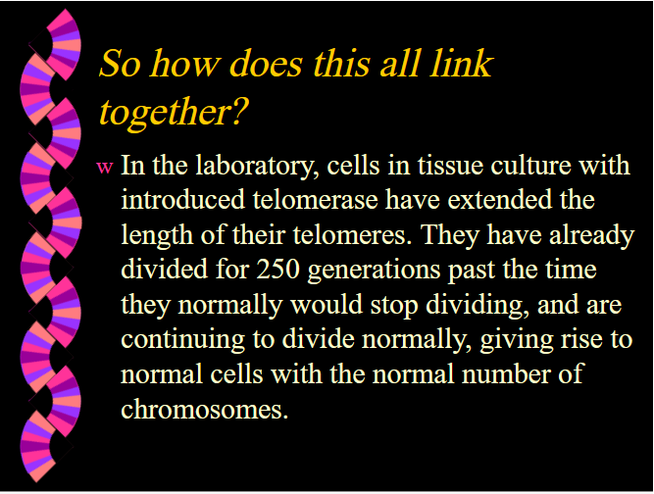

(*Image In the laboratory, human cells in tissue culture with introduced telomerase have extended the length of their telomeres. They have already divided for 250 generations past the time they normally would stop dividing and are continuing to divide normally, giving rise to normal cells with the normal number of chromosomes.)

All of this was accomplished by simple telomere lengthening.

### Future Considerations and Theory

While the focus is on telomere extension, it is crucial to consider and monitor potential risks and challenges. Telomere extension can be done by expressing telomerase.

Theory

We need to lengthen telomerase in all our cells, not just our stem cells. Lengthening telomeres will make senescent cells regain their functionality again.

What is telomerase?

The telomerase enzyme is primarily composed of two core components: the telomerase RNA component (TERC or hTR) and the telomerase reverse transcriptase (hTERT). hTERT is the catalytic subunit of telomerase and is crucial for its activity. While TERC is usually present in cells, the expression of hTERT is tightly regulated. In many somatic (non-germline) cells, hTERT expression is turned off, but it needs to be activated for telomerase to function.

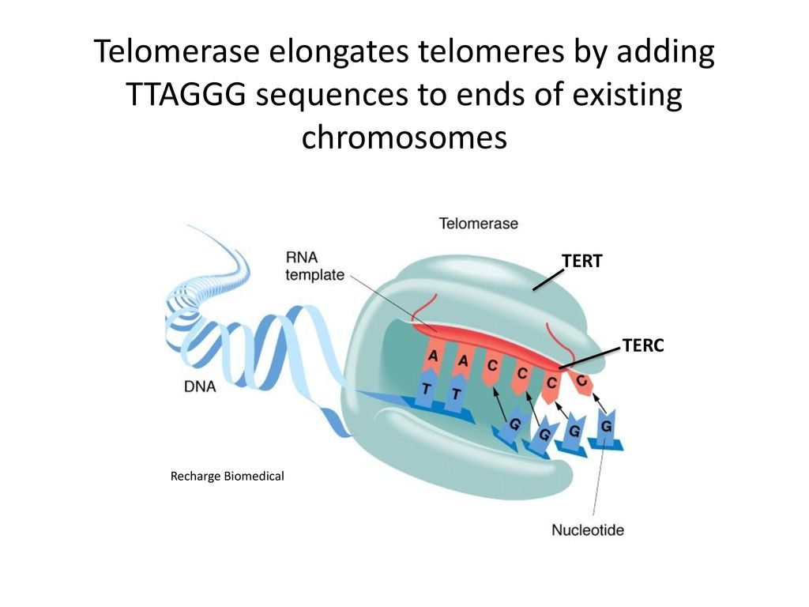

(*image Telomerase enzyme with TERT and TERC)

To get "full telomerase activity", Bill Andrews said that he mixed the protein component and the rna component in vitro and he got full telomerase activity. The cells stopped aging. Aging was reversed by every method of measurement because of this according to bill andrews. This experiment demonstrates that TERT and TERC are the minimal components necessary for telomerase activity. And to get full telomerase ability we need high levels of each.

Thus, we need to focus on enhancing TERT and TERC maximally to get full telomerase activation safely and effectively.

For TERT

The goal is to inhibit a repressor protein, to activate TERT and get near full expression safely.

A method to do so, is the inhibition of a repressor protein F13.

" the specific TERT repressor protein

is the human f13 TERT repressor protein

the subject repressor protein inhibit expression of TERT, where-by inhibit expression is meant that expression of TERT is reduced by at least about 50%, usually at least about 75% and more usually at least about 90% as compared to a control system where TERT expression occurs and that is identical but for the absence of the subject repressor protein.

"https://patents.justia.com/patent/7211435

Therefore, if we completely repress this protein we can have at least 90% activation of TERT. The risks for side effects are also minimal as Sierra Sciences is targeting these proteins and they have very little side effects so far according to the TAM818 molecule.

(*Image of repressor protein on the regulator site for telomerase, and it can be lifted by an anti-aging therapeutic to get telomerase activation)

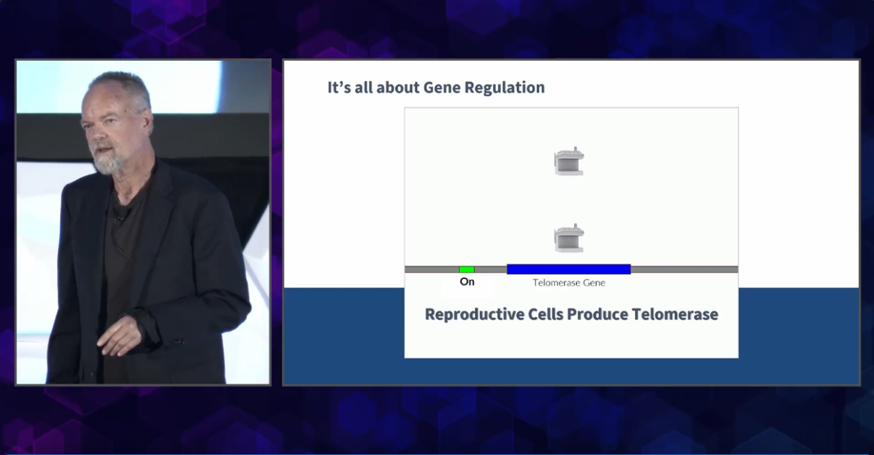

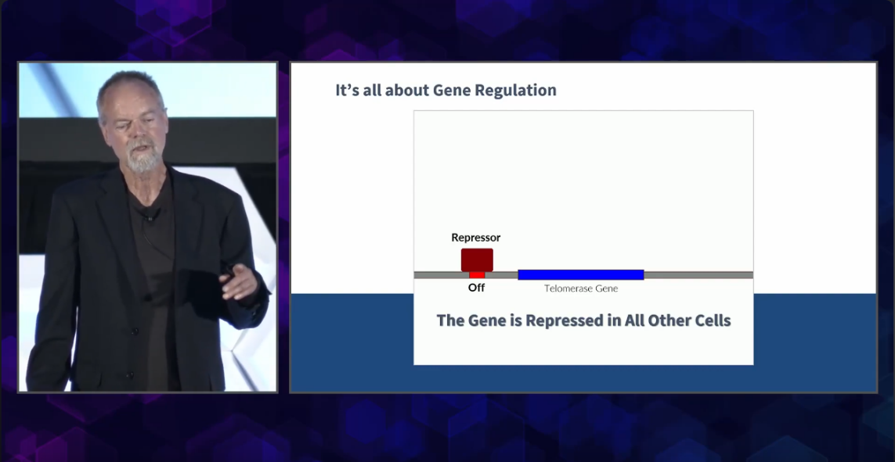

(*Image of chromosome line with red protein on regulator site of the telomerase gene, and on the right is no telomerase production. Image on the bottom is the same, but there is a green chemical that binds to the repressor protein to lift it and enable telomerase production.)

**F13:**

* **TERT Repressor:** F13 is described as a protein that inhibits the expression of TERT. TERT is an enzyme that plays a crucial role in maintaining the length of telomeres, which are structures at the ends of chromosomes.
* **Amino Acid Sequence:** The patent provides the amino acid sequence of F13 (SEQ ID NO:09), which can be used for further identification and study of this protein.

MEVNCLTLKDLISPRQPRLDFAVEDGENAQKENIFVDRSRMAPKTPIKNE PIDLSKQKKFTPERNPITPVKLVDRQQAEPWTPTANLKMLISAASPDIRD REKKKGLFRPIENKDDAFTDSLQLDVVGDSAVDEFEKQRPSRKQKSLGLL CQKFLARYPSYPLSTEKTTISLDEVAVSLGVERRRIYDIVNVLESLHLVS RVAKNQYGWHGRHSLPKTLRNLQRLGEEQKYEEQMAYLQQKELDLIDYKF GERKKDGDPDSQEQQLLDFSEPDCPSSSANSRKDKSLRIMSQKFVMLFLV SKTKIVTLDVAAKILIEESQDAPDHSKFKTKVRRLYDIANVLTSLALIKK VHVTEERGRKPAFKWIGPVDFSSSDEELVDVSASVLPELKRETYGQIQVC AKQKLARHGSFNTVQASERIQRKVNSEPSSPYREEQGSGGYSLEIGSLAA VYRQKIEDNSQGKAFASKRVVPPSSSLDPVAPFPVLSVDPEYCVNPLAHP VFSVAQTDLQAFSMQNGLNGQVDVSLASAASAVESLKPALLAGQPLVYVP SASLFMLYGSLQEGPASGSGSERDDRSSEAPATVELSSAPSAQKRLCEER KPQEEDEPATKRQSREYEDGPLSLVMPKKPSDSTDLASPKTMGNRASIPL KDIHVNGQLPAAEEISGKATANSLVSSEWGNPSRNTDVEKPSKENESTKE PSLLQYLCVQSPAVTSSSDPQEHPTHTS

* **Function:** The inhibition of TERT expression by F13 can be significant, with the patent noting reductions of at least about 50%, usually at least about 75%, and more usually at least about 90% compared to controls.
* To look at the F13 protein and download https://www.ebi.ac.uk/thornton-srv/databases/cgi-bin/pdbsum/GetPage.pl?pdbcode=A4sc
* This protein was obtained by using alphafold to get a 99.9% percentage identity accuracy accuracy via going to a web server that offers AlphaFold predictions. [AlphaFold at EMBL-EBI](https://www.ebi.ac.uk/thornton-srv/databases/cgi-bin/pdbsum/GetPage.pl?pdbcode=index.html&template=alphafold.html)
* For example, if you have two protein sequences:

Sequence 1: AGTCAGTC

Sequence 2: AGTCCGTC

There are 6 identical positions out of 8, so the percentage identity is (6/8)*100 = 75%.

**For TERC**

TERC is thought to be abundant and ubiquitously expressed

1. **Ubiquitous Expression of TERC**: TERC, as the RNA component of telomerase, is ubiquitously expressed across various cell types throughout the body. This widespread expression ensures that TERC is available in cells when needed.
2. **Functional Dependency on TERT**: Despite its ubiquitous presence, TERC requires the protein component, TERT, for telomerase to be functionally active. Most somatic cells have TERC but lack TERT expression, rendering telomerase inactive. Therefore, enhancing TERT activation becomes the primary target to activate telomerase.
3. **Empirical Evidence from Cellular Studies**: Studies on human cells in vitro have demonstrated that introducing telomerase (via TERT) can extend telomere length, resulting in extended cellular lifespan. This shows that as long as TERT is available and active, it can utilize the ubiquitously present TERC to function.
4. **Comparative Analysis with Germ Cells**: Germ cells, which include egg and sperm cells, have active telomerase throughout life. These cells have both TERC and TERT, with TERT being the differentiating factor that allows telomerase activity. This showcases that even in nature, where TERC is consistently available, TERT becomes the determining factor for telomerase activity.
5. **Final Thoughts**: Given the consistent and ubiquitous expression of TERC, the focus should be on optimizing TERT activation. Achieving 90% TERT activation would ensure telomerase activity is sufficiently high to halt or even reverse aging processes at the cellular level. The presence of TERC in cells, coupled with enhanced TERT activity, provides a promising avenue for anti-aging interventions.

TERC is sufficiently abundant thus the section for TERC is solved.

**Risks**

Cancer activation - however telomerase does not cause cancer, rather cancer activates telomerase to be immortal. It is irrelevant for cancer to have long telomeres as long as the immune system is healthy because it can eliminate those cells. We have remedies and treatments for cancer already. The issue with cancer activation is that if do not properly identify the repressor protein for the telomerase gene and mistakenly target another protein. Or we cause off-target effects from the chemical. However, cancer is not inherent to the project.

hTERT elongates short telomeres and shortens long telomeres.

**The scale for effectiveness**

When human cells inside the body become negligibly senescent / we can reverse aging.

**Compare to other telomerase activating molecules**

Other telomerase activating molecules are potent enough to extend the length of telomeres in all cells, but have a preference for lengthening the most critically short telomeres. This means that we have two options.

* We can design an easy to synthesize compound that massively inhibits the repressor protein with relative ADME.
* We can massively boost the ADME properties of an easy to synthesize compound, with decent telomerase lengthening abilities.

### Methods for Telomere Resetting

The goal is to understand how some molecules activate telomerase, potentially by the identification of binding sites to the f13 protein.

We have the cycloastragenol compound and we have identified several potential binding locations for inhibition.

There are no adverse side effects reported with cycloastragenol. "I can sum it by saying that after 4 years on the product at high doses and as many years interacting with customers it is extremely well tolerated, and there have been no official reports of side effects. In addition in the lab the LD 50 is 200x the human dosing at least. The human trials that were done found the same but are not considered "gold standard" because of their design. There have been a very few incidences of potential side effects but no one (the client nor myself) was sure it was TA-65 because stopping and restarting did not bring the problem back. Right now, the company has instructed all distributors not to use the product in people with auto immune disease history because of a theoretical reactivation of the disease process but no such reactivations have been see prior. Personally I may be a little bit more sun sensitive on the high doses."

Once we have identified the locations, we can begin designing a simple to synthesize compound from scratch that can bind to these sites with safety and significant ADME properties in mind. We would probably have to increase the STICKING to the f13 protein.

The strategic approach to developing a molecule for reversing aging through telomere extension involves a systematic and phased methodology. This section outlines the steps and considerations in the process:

#### 1. **Understanding Telomerase Activation:**

* **Biology of Telomerase:** Delve deep into the biology of telomerase, understanding its activation mechanisms, structure, function, and associated proteins.

We can ask chatgpt, if the method so far is indeed correct.

#### 2. **Target Identification:**

* **Drug Targets:** Identify potential craters within the F13 protein that are targets for binding, to inhibit.

#### 3. **In Silico Drug Design:**

* **Computational Design:** Utilize computational methods to design molecules capable of interacting with identified targets effectively.
* **SBDD & LBDD Techniques:** Employ Structure-Based Drug Design (SBDD) and Ligand-Based Drug Design (LBDD) techniques for precise molecular design.
* **Molecular Docking:** Predict the interaction between designed molecules and targets using molecular docking techniques.

#### 4. **ADME/Tox Prediction:**

* **Pharmacokinetics Prediction:** Estimate the Absorption, Distribution, Metabolism, Excretion, and Toxicity (ADME/Tox) properties of designed molecules using in silico tools.
* **Toxicity Assessment:** Evaluate potential toxicity early in the design phase to ensure safety and efficacy.

#### 5. **In Vitro Testing:**

* **Molecule Synthesis:** Synthesize designed molecules and evaluate their activity through cell-based assays.
* **Telomerase Activation Assessment:** Test the molecules’ ability to activate telomerase in relevant cell lines and assess toxicity.

#### 6. **In Vivo Testing:**

* **Animal Model Testing:** Evaluate the efficacy and toxicity of promising candidates in animal models to understand their physiological impacts.

#### 7. **Optimization:**

* **Molecule Refinement:** Based on testing results, optimize the molecules to enhance their activity while minimizing toxicity.
* **Molecular Modeling Software:** MOE, Schrodinger Suite, Discovery Studio.
* **ADME/Tox Prediction Tools:** ADMET Predictor, PreADMET, SwissADME.
* **Molecular Docking Software:** AutoDock, DOCK, Glide.

### Considerations:

* **High-Throughput Screening:** Lower cost per compound, uses existing compound libraries, bulk purchases.

But most existing compounds have already been tested, and it is unlikely for an existing compound to activate telomerase to the extent we need it to be and also be safe. Therefore, we need to custom synthesize new molecules.

* **Custom Synthesis:** Higher cost, creating new molecules not available in libraries, specialized process chatgpt gave numbers of $2000-20,000 for the synthesis of new molecules.

However, if the new molecule is able to achieve the objective then Bill Andrews says he could mass produce it for less than $1 per person. Also, according to the TAM818 molecule, we need very little of it to actually make a very big difference. So, we could just chemically synthesize the molecule and there is lots of potential.

Once a compound is found that is likely to be very successful, we can send it to Dr. Bill Andrews to synthesize and produce and sell. Obviously, we can make the compound open sourced, because the ultimate solution is found and we can explain how to simply synthesize the compound.